RATIO
Pearson Edexcel - Tuesday 19 May 2020 - Paper 1 (Non-Calculator) Foundation Tier

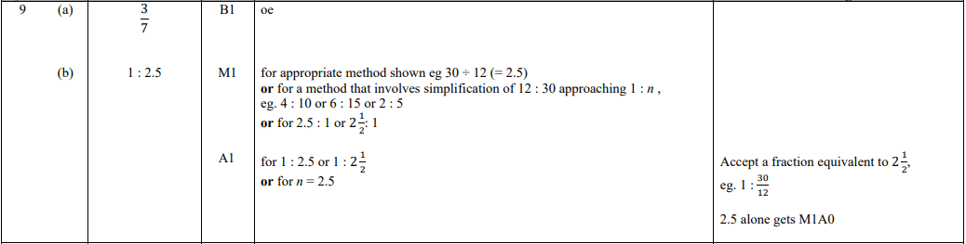

Pearson Edexcel - Thursday 4 June 2020 - Paper 2 (Calculator) Foundation Tier

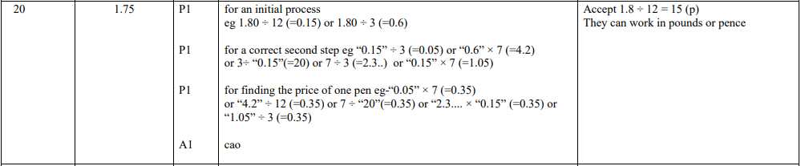

Pearson Edexcel - Tuesday 21 May 2019 - Paper 1 (Non-Calculator) Foundation Tier

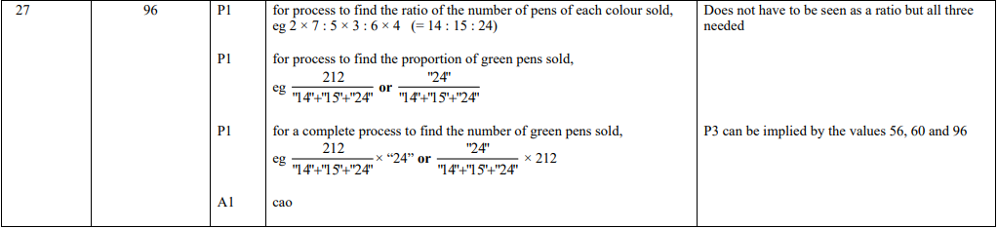

Pearson Edexcel - Thursday 6 June 2019 - Paper 2 (Calculator) Foundation Tier

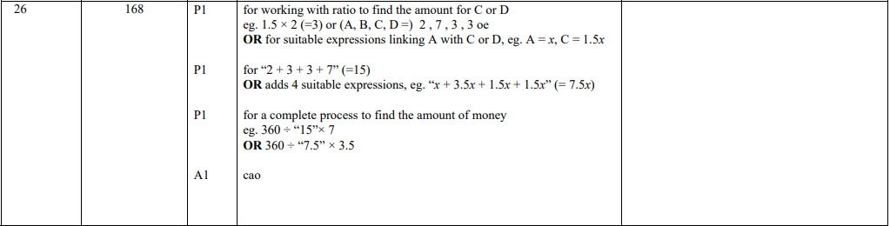

Pearson Edexcel - Tuesday 11 June 2019 - Paper 3 (Calculator) Foundation Tier

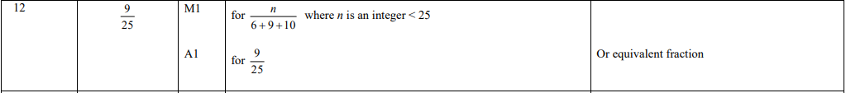

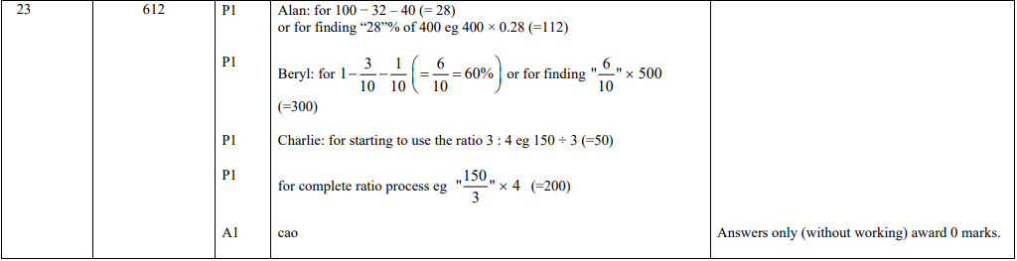

Pearson Edexcel - Tuesday 6 November 2018 - Paper 1 (Non-Calculator) Foundation Tier

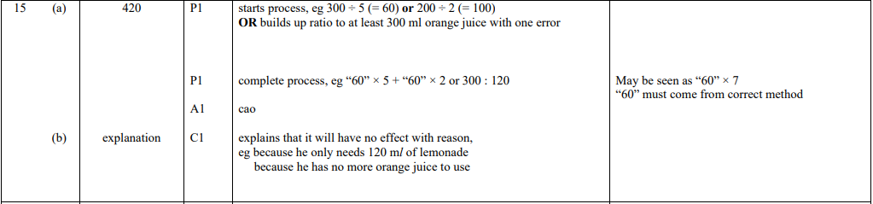

Pearson Edexcel - Thursday 24 May 2018 - Paper 1 (Non-Calculator) Foundation Tier

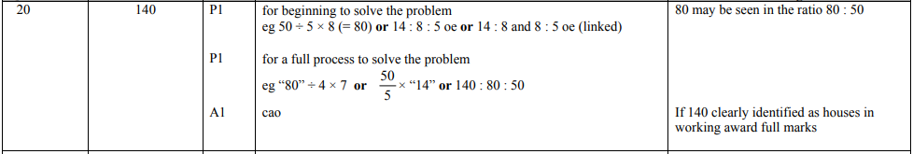

Pearson Edexcel - Tuesday 12 June 2018 - Paper 3 (Calculator) Foundation Tier

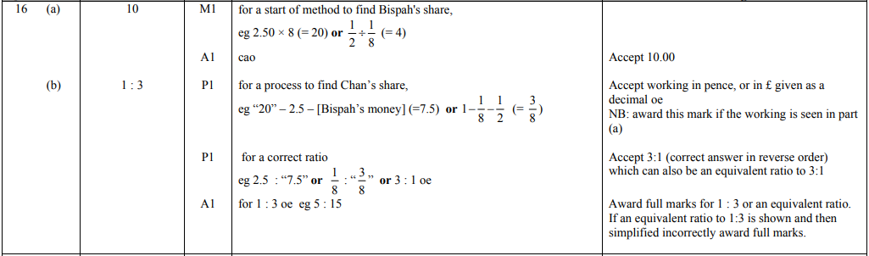

Pearson Edexcel - Thursday 2 November 2017 - Paper 1 (Non-Calculator) Foundation Tier

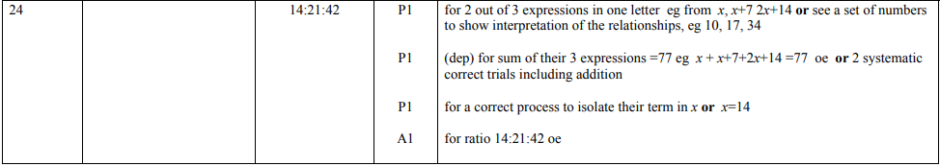

Pearson Edexcel - Monday 6 November 2017 - Paper 2 (Calculator) Foundation Tier

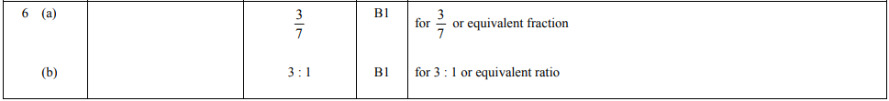

Pearson Edexcel - Wednesday 8 November 2017 - Paper 3 (Calculator) Foundation Tier

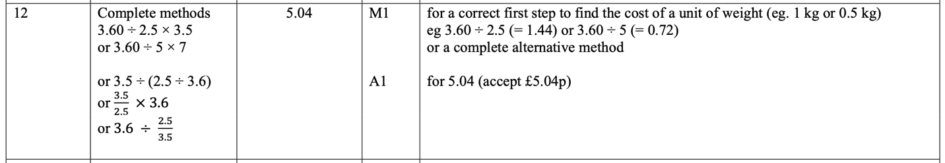

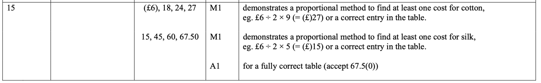

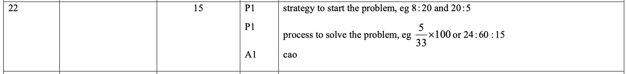

Pearson Edexcel – Specimen 2 - Paper 1 (Non-Calculator) Foundation Tier

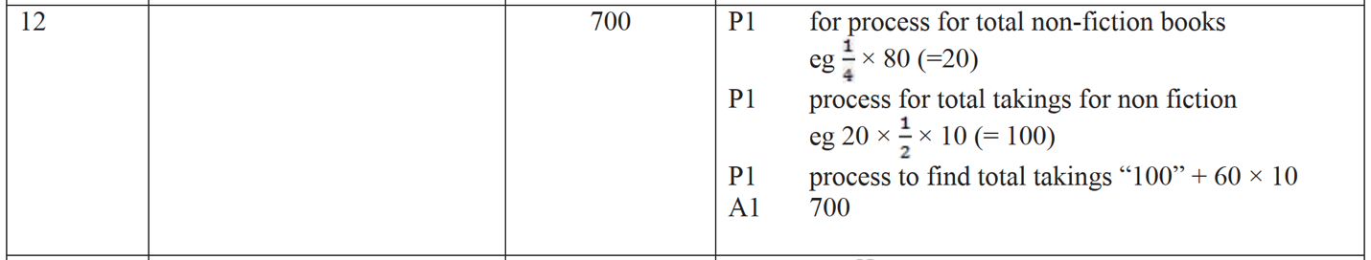

Pearson Edexcel – Specimen 2 - Paper 2 (Calculator) Foundation Tier

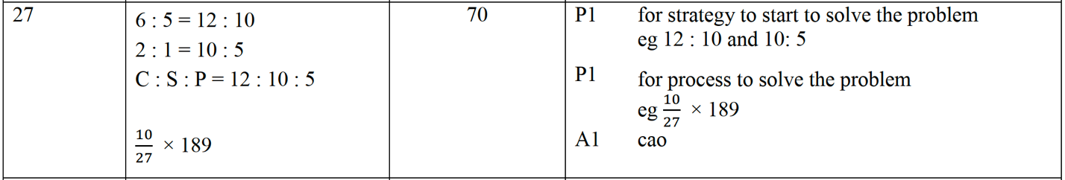

Pearson Edexcel – Specimen 2 - Paper 3 (Calculator) Foundation Tier

Pearson Edexcel – Sample Paper 1 (Non-Calculator) Foundation Tier
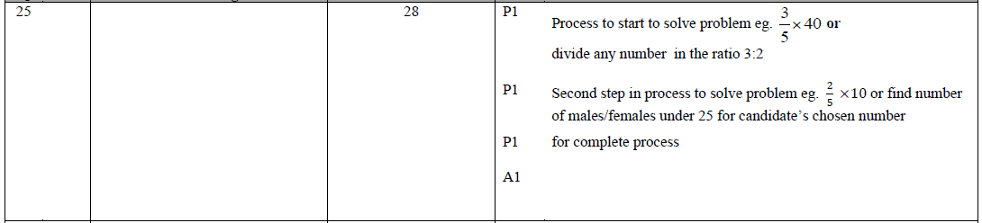

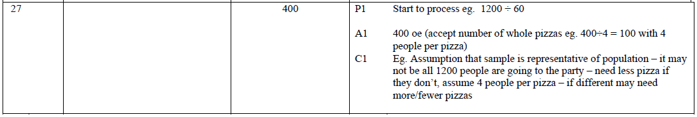

OCR – Tuesday 03 November 2020- Morning - Paper 1 (Calculator) Foundation Tier

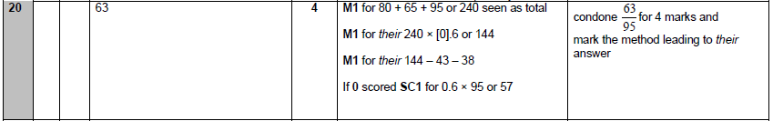

OCR Monday 11 November 2019 – Afternoon (Calculator) Foundation Tier

OCR Tuesday 21 May 2019 – Morning (Calculator) Foundation Tier
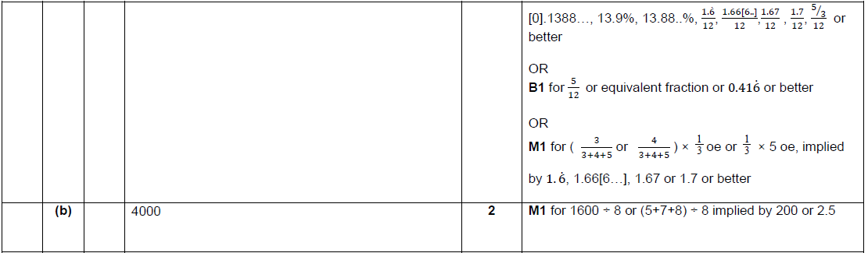

OCR Tuesday 6 November 2018 – Morning (Calculator) Foundation Tier

OCR Thursday 8 November 2018 – Morning (Non-Calculator) Foundation Tier
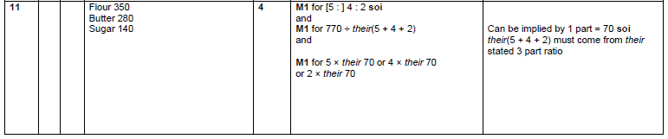

OCR Monday 24 May 2018 – Morning (Calculator) Foundation Tier
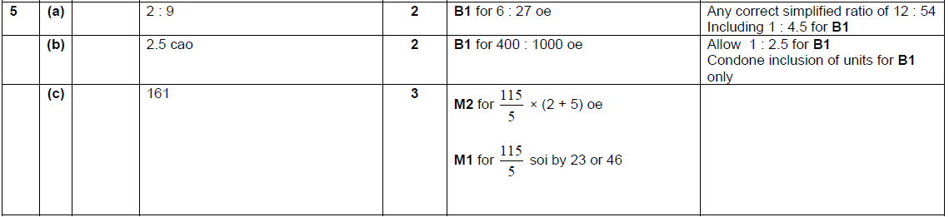

OCR Thursday 7 June 2018 – Morning (Non Calculator) Foundation Tier
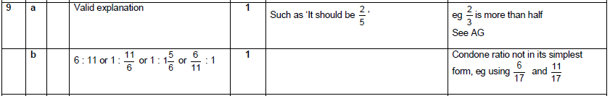

OCR Tuesday 12 June 2018– Morning (Calculator) Foundation Tier
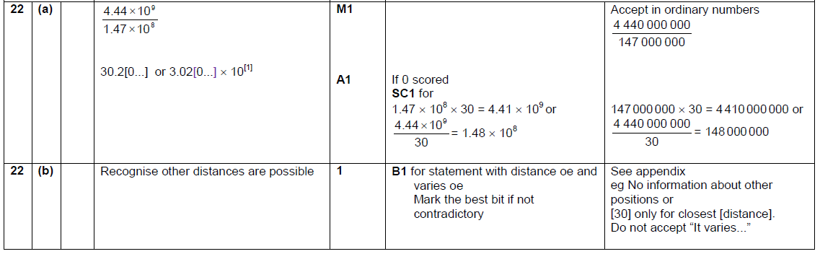

OCR Thursday 2 November 2017– Morning (Calculator) Foundation Tier
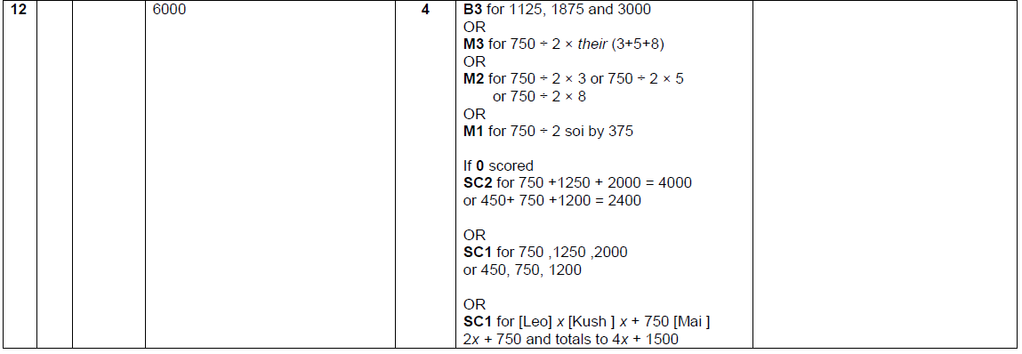

OCR Monday 6 November 2017– Morning (Calculator) Foundation Tier
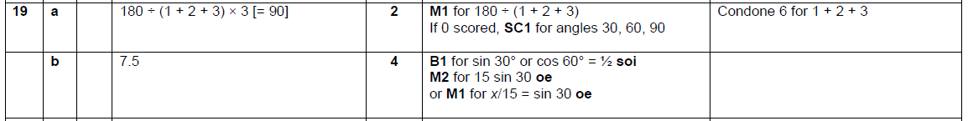

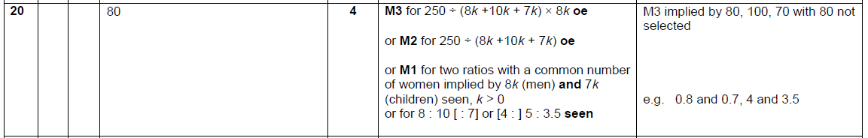

Pearson Edexcel – Sample Papers - Paper 1 (Non-Calculator) Foundation Tier

Pearson Edexcel –Sample Papers - Paper 2 (Calculator) Foundation Tier

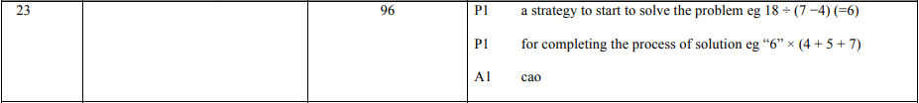
OCR Wednesday 8 November 2017– Morning (Calculator) Foundation Tier

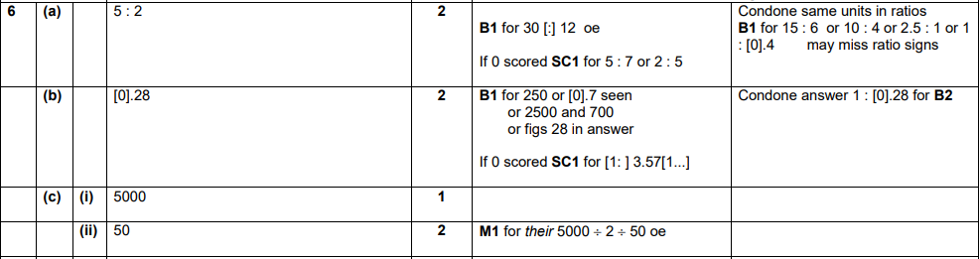

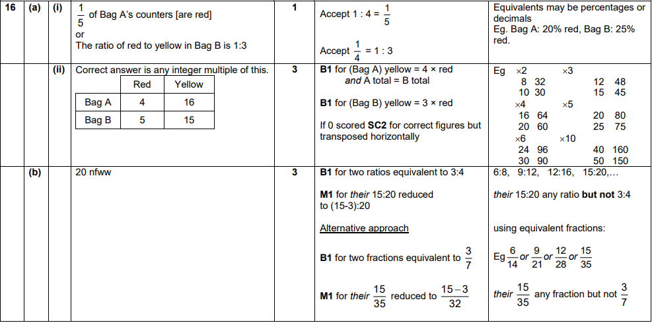

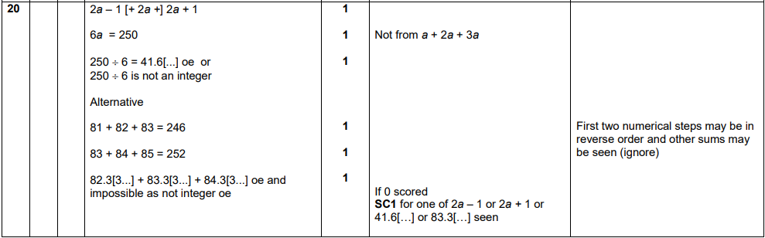
OCR Thursday 25 May 2017 – Morning (Calculator) Foundation Tier

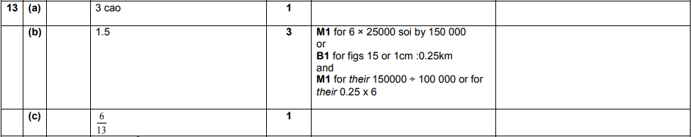

OCR Thursday 8 June 2017 – Morning (Non - Calculator) Foundation Tier

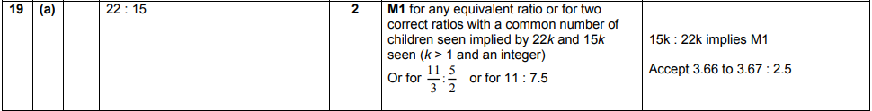
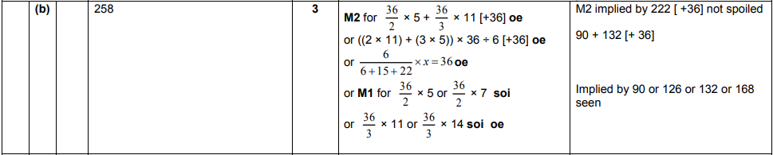
OCR Sample Question Paper 1 – Morning/Afternoon (Calculator) Foundation Tier

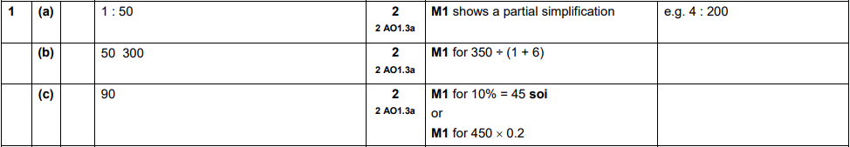
OCR Sample Question Paper 3 – Morning/Afternoon (Calculator) Foundation Tier

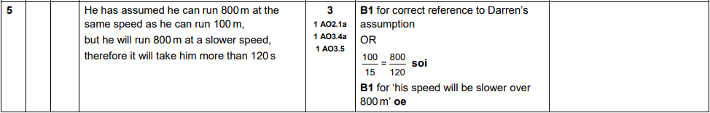

AQA Tuesday 19 May 2020 – Morning (Non-Calculator) Foundation Tier

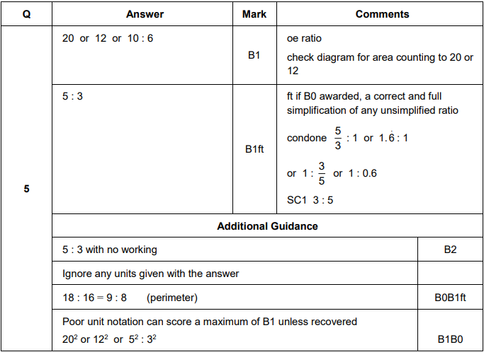

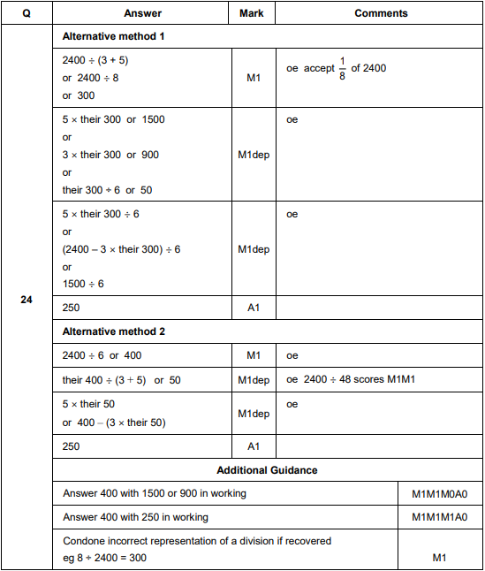
AQA Thursday 4 June 2020 – Morning (Calculator) Foundation Tier

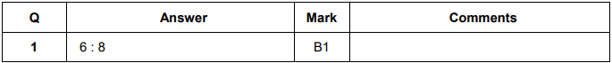

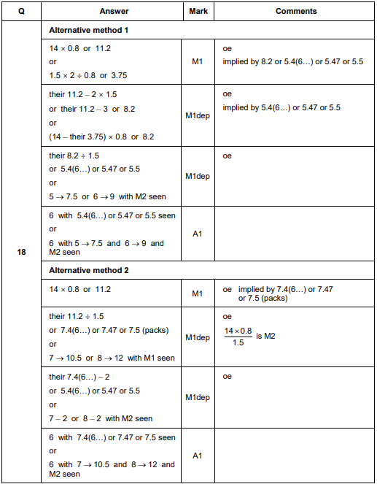

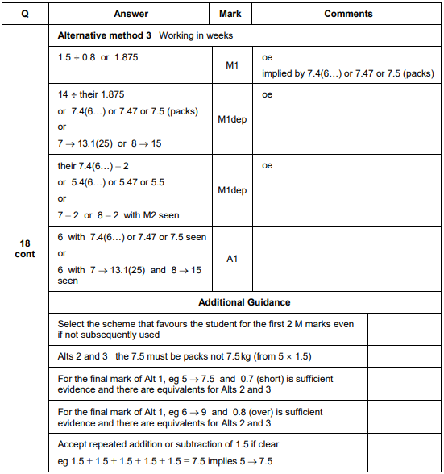

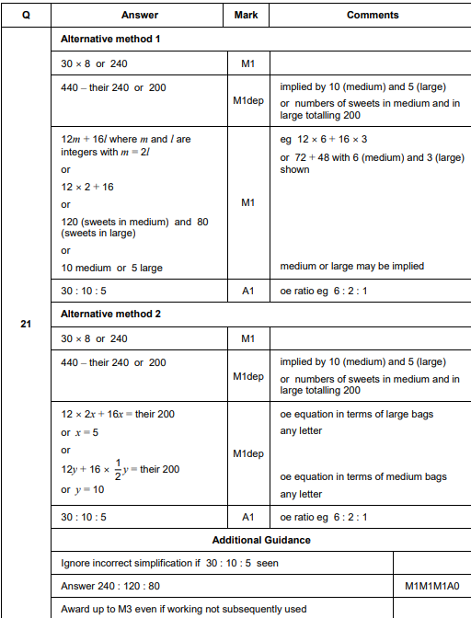

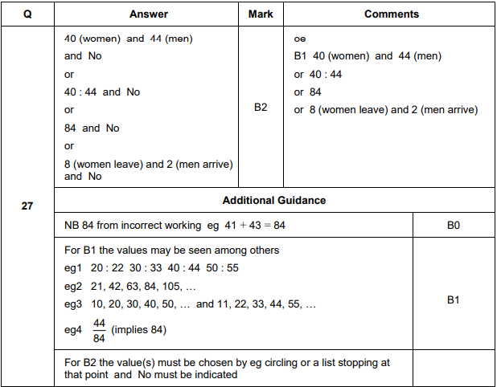

AQA Monday 8 June 2020 – Morning (Calculator) Foundation Tier

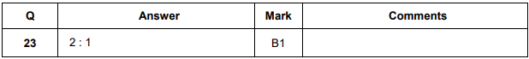
AQA Tuesday 21 May 2019 – Morning (Non-Calculator) Foundation Tier

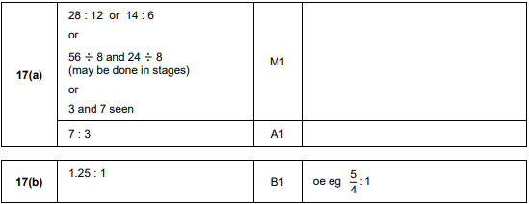
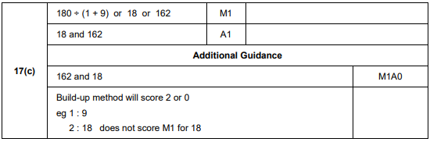
AQA Thursday 6 June 2019 – Morning (Calculator) Foundation Tier

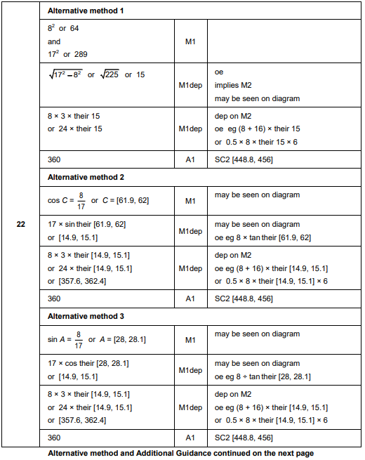
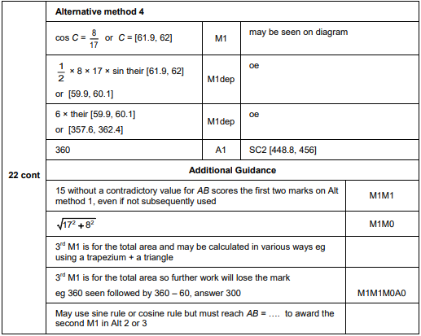

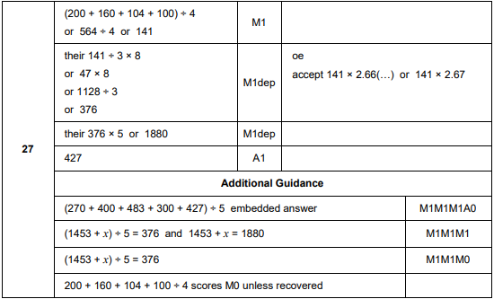

AQA Tuesday 6 November 2018 – Morning (Non-Calculator) Foundation Tier

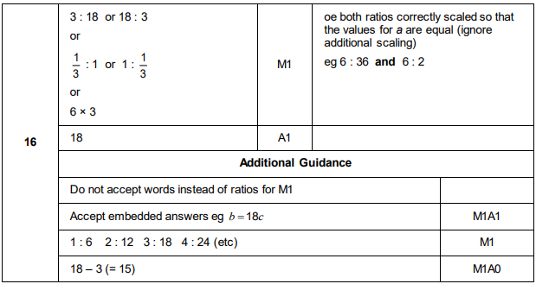
AQA Thursday 8 November 2018 – Morning (Calculator) Foundation Tier

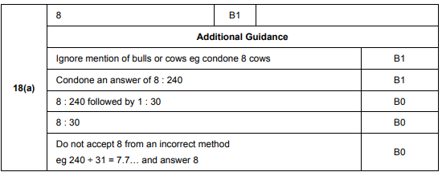
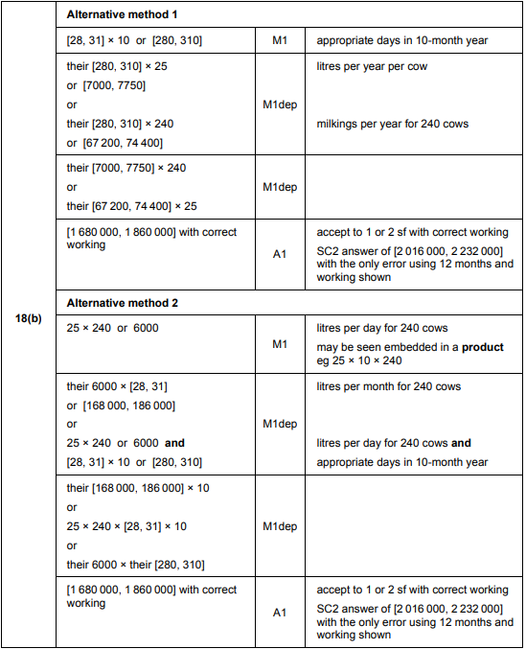

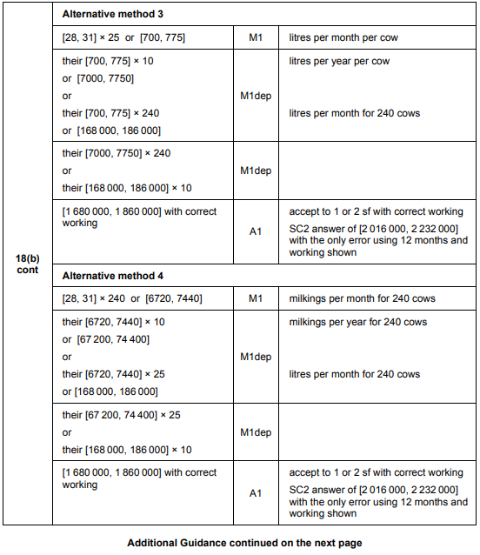
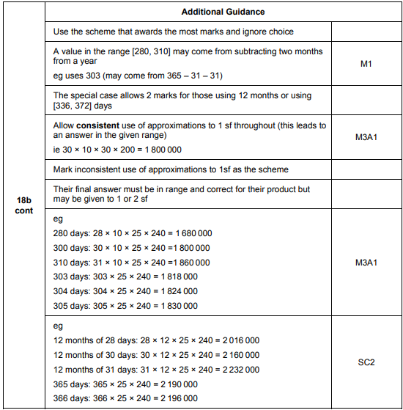

AQA Monday 12 November 2018 – Morning (Calculator) Foundation Tier

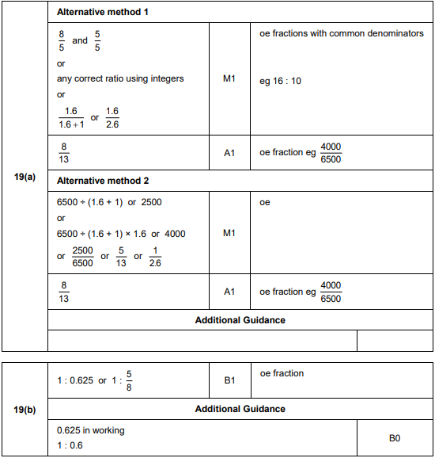

AQA Thursday 24 May 2018 – Morning (Non-Calculator) Foundation Tier

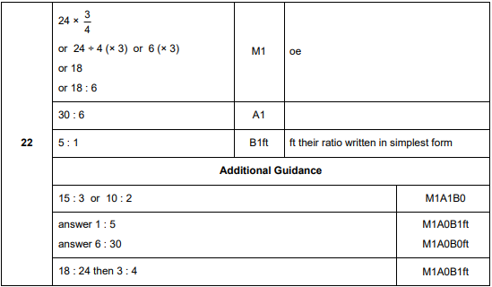
AQA Thursday 24 May 2018 – Morning (Non-Calculator) Foundation Tier

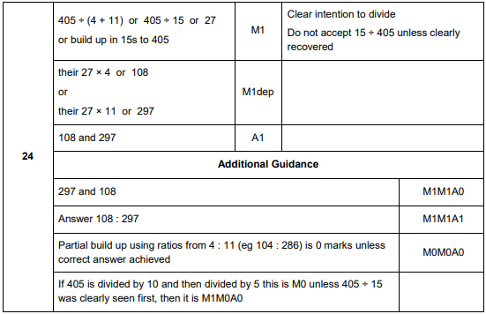

AQA Thursday 7 June 2018 – Morning (Calculator) Foundation Tier

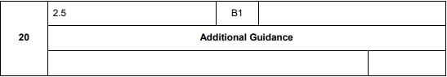
AQA Thursday 7 June 2018 – Morning (Calculator) Foundation Tier

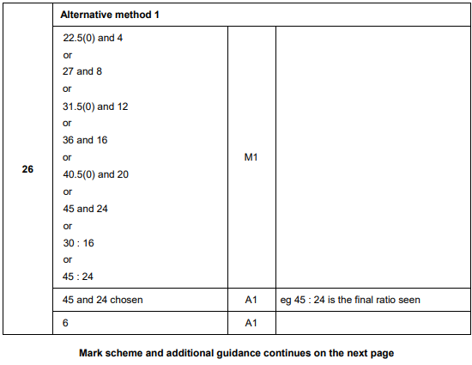
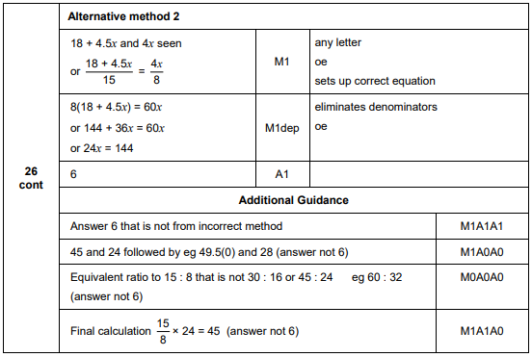
AQA Thursday 2 November 2017 – Morning (Non-Calculator) Foundation Tier

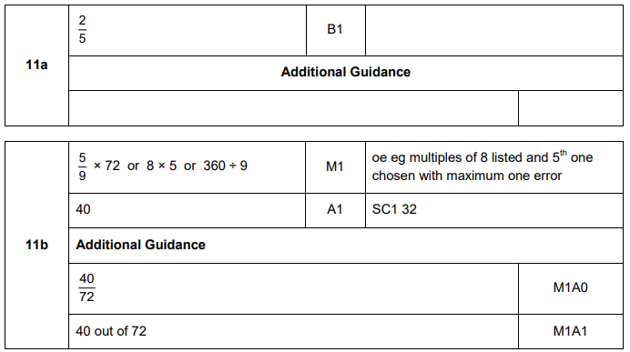

AQA Monday 6 November 2017 – Morning (Calculator) Foundation Tier

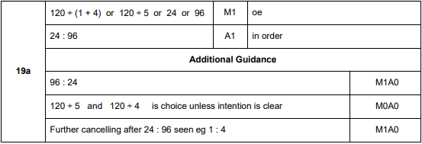
AQA Thursday 25 May 2017– Morning (Non-Calculator) Foundation Tier

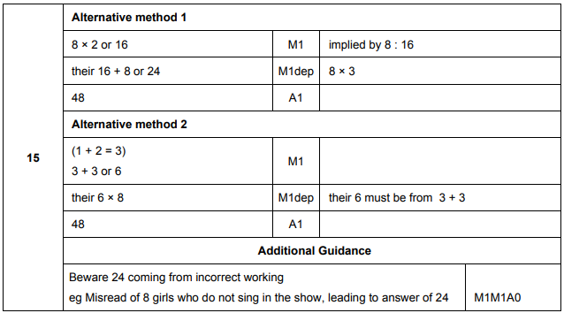

AQA Thursday 8 June 2017– Morning (Calculator) Foundation Tier

AQA Thursday 8 June 2017– Morning (Calculator) Foundation Tier

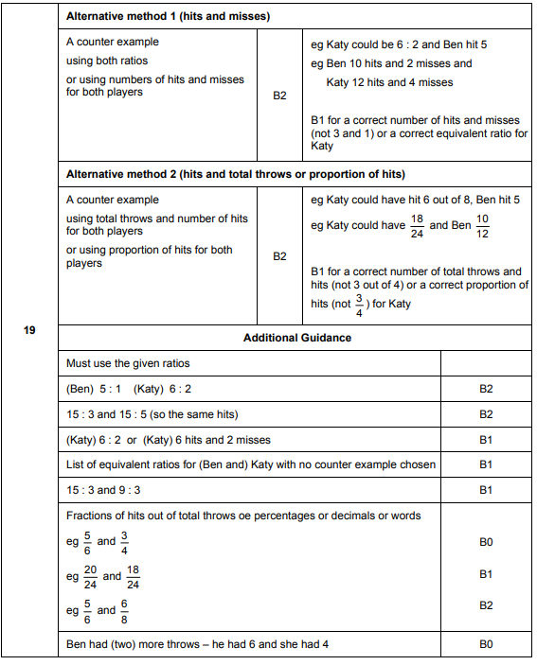

AQA Tuesday 13 June 2017 Morning– Morning (Calculator) Foundation Tier

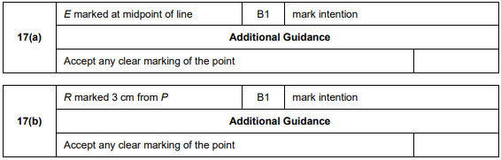
AQA Tuesday 13 June 2017 Morning– Morning (Calculator) Foundation Tier

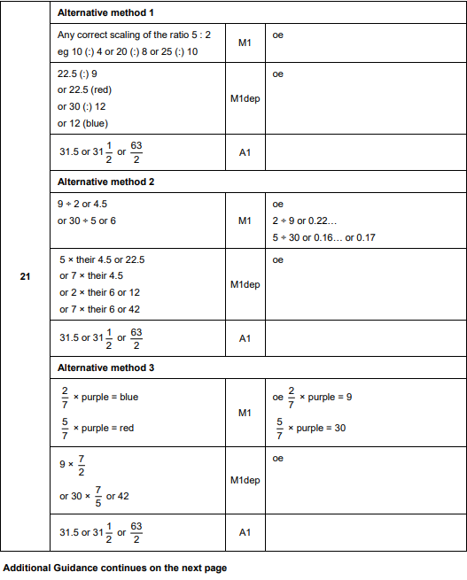
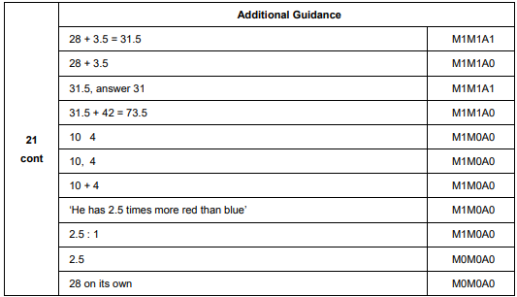
AQA Sample Paper 1– Morning (Non-Calculator) Foundation Tier

AQA Sample Paper 1– Morning (Non-Calculator) Foundation Tier

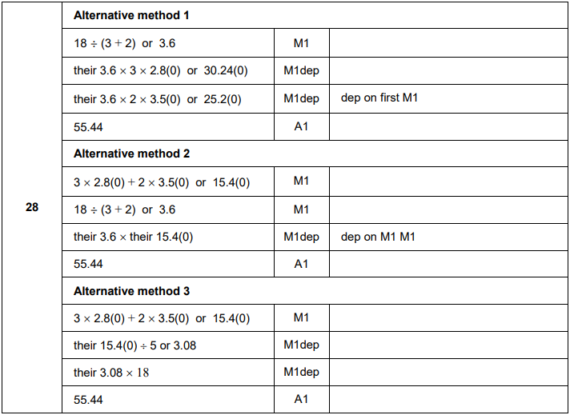
AQA Sample Paper 2– Morning (Calculator) Foundation Tier

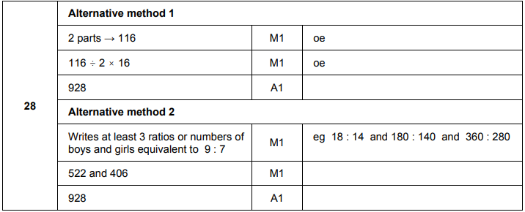

AQA Sample Paper 3– Morning (Calculator) Foundation Tier

